File Extension
# Source: AI Source: Provided by: [Data Path: Persons Table -> ID Column: 1, Name_En Column: Motasem Essam] -> From: [Chatgpt (GPT‑5 Mini)] on [12/10/2025]
A File Extension is a suffix at the end of a file name that indicates the type of file and what program can open it. It usually comes after a dot (.) in the file name.

Definition
# Source: AI Source: Provided by: [Data Path: Persons Table -> ID Column: 1, Name_En Column: Motasem Essam] -> From: [Chatgpt (GPT‑5 Mini)] on [12/10/2025]
- File extension tells the operating system and users what kind of data the file contains.
- It also helps the system choose the right application to open the file.
Example:

document.txt
image.jpg
song.mp3
- .txt → Text file
- .jpg → Image file
- .mp3 → Audio file

Key Points
# Source: AI Source: Provided by: [Data Path: Persons Table -> ID Column: 1, Name_En Column: Motasem Essam] -> From: [Chatgpt (GPT‑5 Mini)] on [12/10/2025]
- Usually 2–4 letters after the dot.
- Case-insensitive in most systems (.TXT and .txt are treated the same).
- Determines how the file is handled by the computer.
- Changing the extension does not change the file content, but may make it unreadable by programs.

Common File Extensions
# Source: AI Source: Provided by: [Data Path: Persons Table -> ID Column: 1, Name_En Column: Motasem Essam] -> From: [Chatgpt (GPT‑5 Mini)] on [12/10/2025]
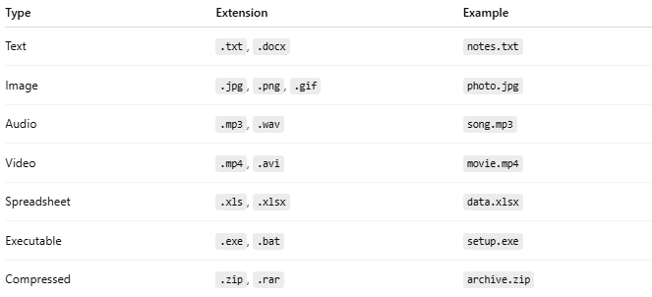
Type | Extension | Example
Text | .txt, .docx | notes.txt
Image | .jpg, .png, .gif | photo.jpg
Audio | .mp3, .wav | song.mp3
Video | .mp4, .avi | movie.mp4
Spreadsheet | .xls, .xlsx | data.xlsx
Executable | .exe, .bat | setup.exe
Compressed | .zip, .rar | archive.zip

Analogy
# Source: AI Source: Provided by: [Data Path: Persons Table -> ID Column: 1, Name_En Column: Motasem Essam] -> From: [Chatgpt (GPT‑5 Mini)] on [12/10/2025]
- File name → Book title
- File extension → Type of book (novel, dictionary, comic)

